Autism & Sensory-Friendly Santa Comes to Jersey City!

Saturday Dec 17 & 18 from 10-4PM at Jersey City Medical Museum.

Reserve a ticket for your child today at http://bit.ly/AutismSanta

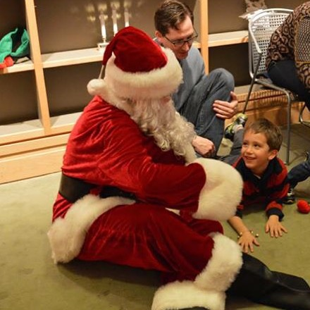

More about the event
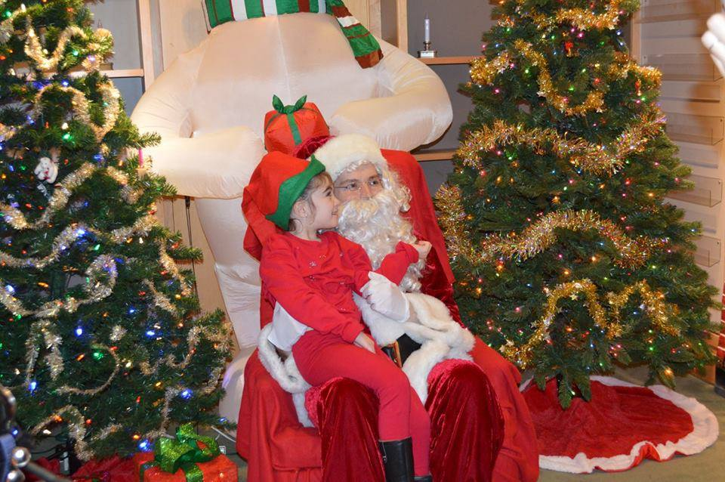

More than just the usual photo opportunity with the "Big Man" of the season, this event promises to deliver over an hour of festive, holiday activities planned for children of all ages and their parents. The little ones will get to dance & sing and get their photo taken with Santa! The event will take place on December 17th and December 18th from 10-4PM! Space is limited! Only 8 children with autism and other special needs per 30 minute time slot - so reserve this wonderful adventure today!! Book at http://bit.ly/AutismSanta or email us at KFMMakingADifference@gmail.com with your preferred date and time and one of our elves will get back to you as soon as possible

NOTE: YOU ONLY NEED TO RESERVE A TICKET FOR YOUR CHILD, DONT GET A TICKET FOR YOURSELF (parents are welcome to join them to help them with their elf making duties). Each child will be sponsored (you can sponsor a child for $20 or more) through donation to attend so please make every effort to stick to your time!

More about Kerry Magro

Kerry Magro is an award winning national speaker who is on the autism spectrum. Kerry now 28-years-old has spoken at over 685 venues across the Country to educate our community on autism and disability awareness. Along with his work as a speaker his book “Defining Autism From The Heart” was an Amazon Best Seller for Special Need Parenting. Learn more about Kerry at Kerrymagro.com/speaking

